Capturas de pantalla de las simulaciones
AND
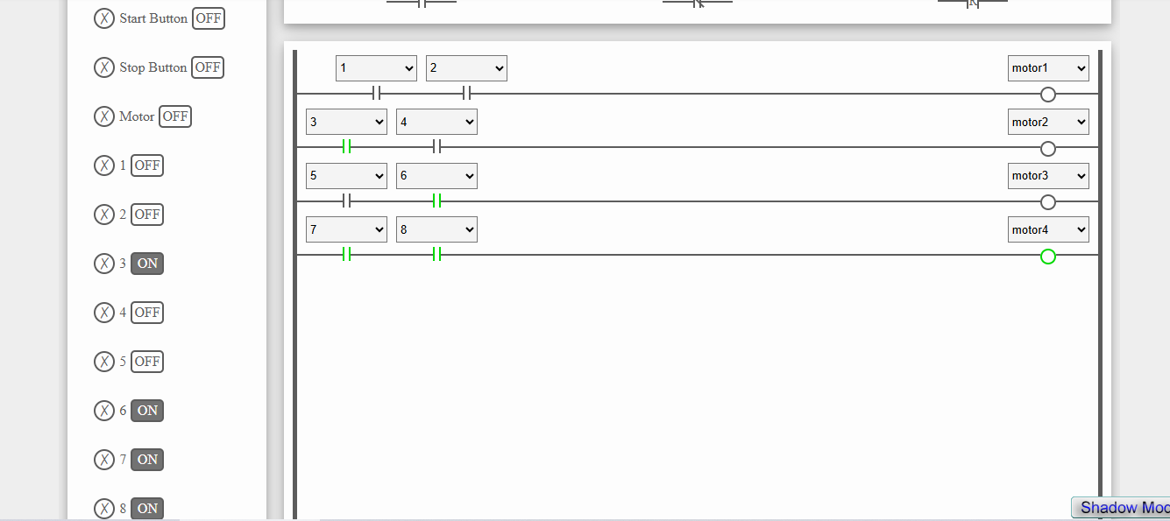
https://www.plcfiddle.com:/fiddles/d160e9ca-9e74-4dfa-ae55-a0fc97165778
NOT
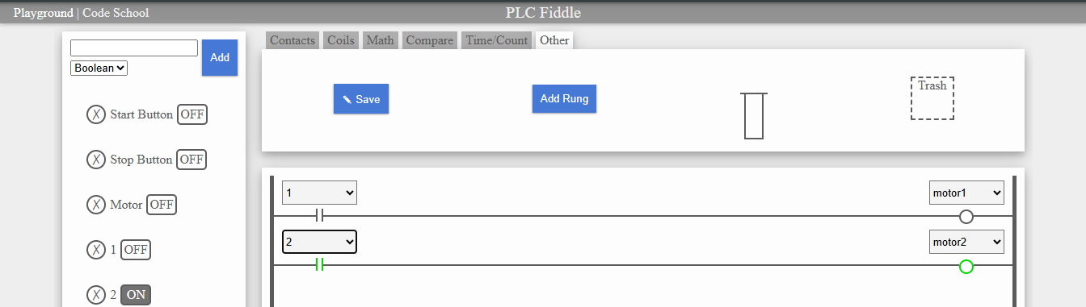
https://www.plcfiddle.com:/fiddles/dd8b74ae-b7db-425a-b7f1-03843e6dbd74}
OR
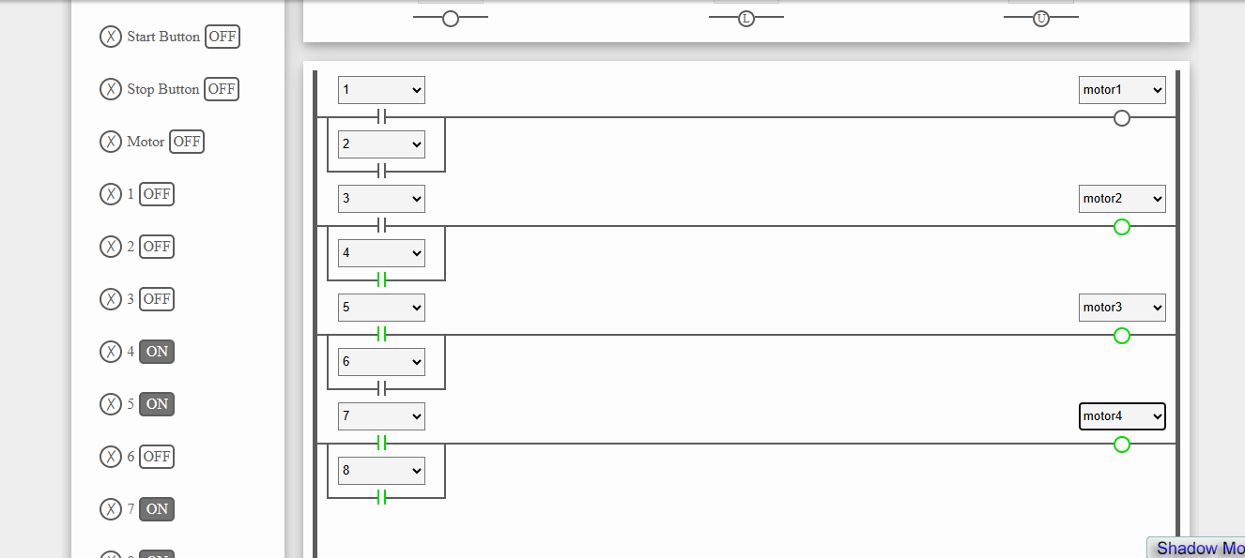
https://www.plcfiddle.com:/fiddles/c8c0b137-e6e6-4913-ad83-2825ee3bd807
NAND
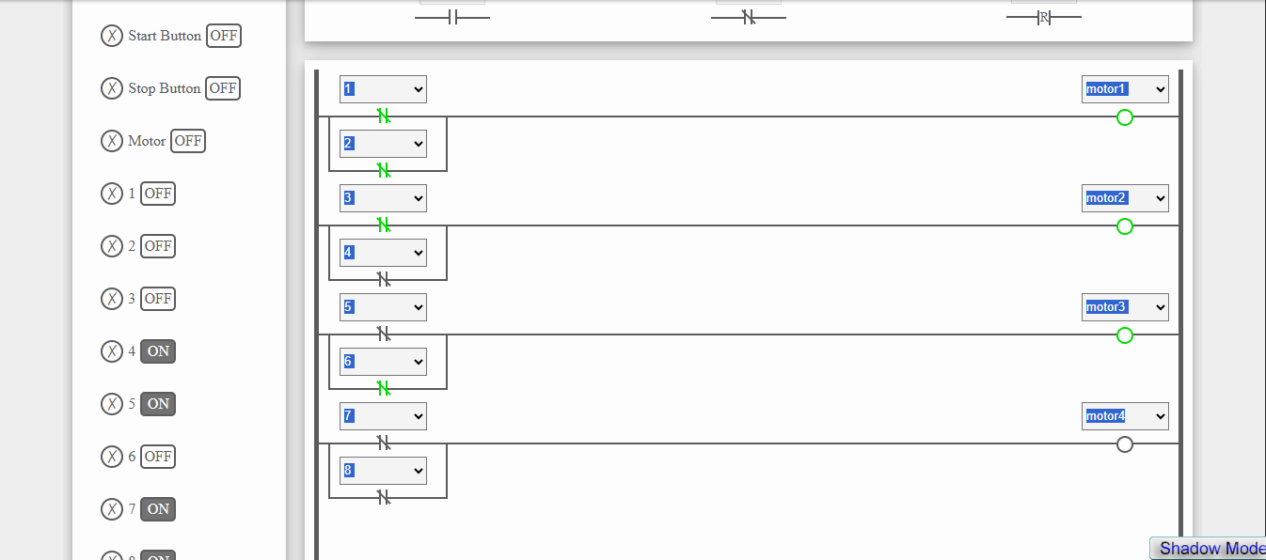
https://www.plcfiddle.com:/fiddles/2c3a7e82-edea-468d-91fd-0ef8e9200c30
NOR
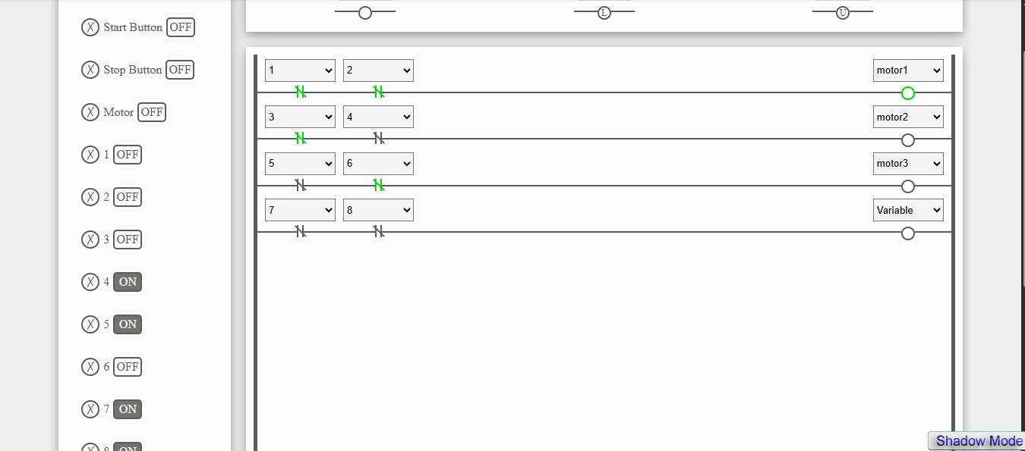
https://www.plcfiddle.com:/fiddles/7313238e-9ef3-4ee5-80a0-1e4666da4d55

